#
# There was a task to install and configure rabbitmq software on three servers.
# I didn’t done it. The owner of the task write to me in slack and he had said he istalled rabbitmq.
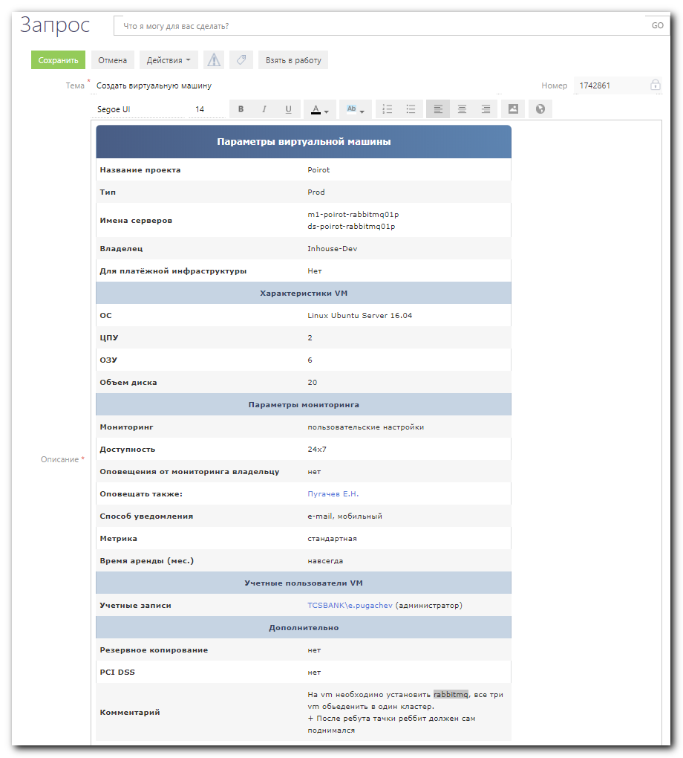

#
# In comments to this article I see this article is too much outdated. This article was posted in 2013 - five years old...

https://www.digitalocean.com/community/tutorials/how-to-install-and-manage-rabbitmq

How To Install and Manage RabbitMQ
PostedDecember 19, 2013 206.4kviews MESSAGING CENTOS DEBIAN UBUNTU
- O.S. Tezer

Introduction
Putting things off for a while instead of immediately doing them can be considered lazy. In fact, most of the time it probably is. However, there are times when it’s absolutely the right thing to do. Occasionally, one needs to delay a time-consuming job for a while; it needs to be queued for future execution so that something more important can be dealt with. For this to happen, you need a broker: someone who will accept messages (e.g. jobs, tasks) from various senders (i.e. a web application), queue them up, and distribute them to the relevant parties (i.e. workers) to make use of them - all asynchronously and on demand.
In this DigitalOcean article, we aim to introduce you to the RabbitMQ project: an open-source message-broker application stack which implements the Advanced Message Queuing Protocol (AMQP) to handle the entirety of the scenario we explained above.

Messaging, Message Brokers and Queues
Messaging is a way of exchanging certain data between processes, applications, and servers (virtual and physical). These messages exchanged, helping with certain engineering needs, can consist of anything from plain text messages to blobs of binary data serving to address different needs. For this to work, an interface managed by a third party program (a middleware) is needed… welcome Message Brokers.
Message Brokers are usually application stacks with dedicated pieces covering the each stage of the exchange setup. From accepting a message to queuing it and delivering it to the requesting party, brokers handle the duty which would normally be much more cumbersome with non-dedicated solutions or simple hacks such as using a database, cron jobs, etc. They simply work by dealing with queues which technically constitute infinite buffers, to put messages and pop-and-deliver them later on to be processed either automatically or by polling.

Why use them?
These message brooking solutions act like a middleman for various services (e.g. your web application). They can be used to greatly reduce loads and delivery times by web application servers since tasks, which would normally take quite bit of time to process, can be delegated for a third party whose sole job is to perform them (e.g. workers). They also come in handy when a more "guaranteed" persistence is needed to pass information along from one place to another.

When to use them?
All put together, the core functionality explained expands to cover a multitude of areas, including-but-not-limited-to:
- Allowing web servers to respond to requests quickly instead of being forced to perform resource-heavy procedures on the spot
- Distributing a message to multiple recipients for consumption (e.g. processing)
- Letting offline parties (i.e. a disconnected user) fetch data at a later time instead of having it lost permanently
- Introducing fully asynchronous functionality to the backend systems
- Ordering and prioritising tasks
- Balancing loads between workers
- Greatly increase reliability and uptime of your application
- and much more

RabbitMQ
RabbitMQ is one of the more popular message broker solutions in the market, offered with an open-source license (Mozilla Public License v1.1) as an implementation of Advanced Message Queuing Protocol. Developed using the Erlang language, it is actually relatively easy to use and get started. It was first published in early 2007 and has since seen an active development with its latest release being version 3.2.2 (December 2013).

How does it work?
RabbitMQ works by offering an interface, connecting message senders (Publishers) with receivers (Consumers) through an exchange (Broker) which distributes the data to relevant lists (Message Queues).
APPLICATION EXCHANGE TASK LIST WORKER
[DATA] -------> [DATA] ---> [D]+[D][D][D] ---> [DATA]
Publisher EXCHANGE Queue Consumer

How is it different than the others?
RabbitMQ, unlike some other solutions, is a fully-fledged application stack (i.e. a message broker). It gives you all the tools you need to work with, instead of acting like a framework for you to implement your own. Being extremely popular, it is really easy to get going using RabbitMQ and to find answers to your questions online.

Advanced Message Queuing Protocol (AMQP) in Brief
AMQP is a widely accepted open-source standard for distributing and transferring messages from a source to a destination. As a protocol and standard, it sets a common ground for various applications and message broker middlewares to interoperate without encountering issues caused by individually set design decisions.

Installing RabbitMQ
RabbitMQ packages are distributed both with CentOS / RHEL & Ubuntu / Debian based systems. However, they are - like with most applications - outdated. The recommended way to get RabbitMQ on your system is therefore to download the package online and install manually.
Note: We will be performing our installations and perform the actions listed here on a fresh and newly created VPS due to various reasons. If you are actively serving clients and might have modified your system, in order to not break anything working and to not to run into issues, you are highly advised to try the following instructions on a new system.

Installing on CentOS 6 / RHEL Based Systems
Before installing RabbitMQ, we need to get its main dependencies such as Erlang. However, first and foremost we should update our system and its default applications.
Run the following to update our droplet:
yum -y update
And let's use the below commands to get Erlang on our system:
# Add and enable relevant application repositories:
# Note: We are also enabling third party remi package repositories.
wget http://dl.fedoraproject.org/pub/epel/6/x86_64/epel-release-6-8.noarch.rpm
wget http://rpms.famillecollet.com/enterprise/remi-release-6.rpm
sudo rpm -Uvh remi-release-6*.rpm epel-release-6*.rpm
# Finally, download and install Erlang:
yum install -y erlang
Once we have Erlang, we can continue with installing RabbitMQ:
# Download the latest RabbitMQ package using wget:
wget http://www.rabbitmq.com/releases/rabbitmq-server/v3.2.2/rabbitmq-server-3.2.2-1.noarch.rpm
# Add the necessary keys for verification:
rpm --import http://www.rabbitmq.com/rabbitmq-signing-key-public.asc
# Install the .RPM package using YUM:
yum install rabbitmq-server-3.2.2-1.noarch.rpm

Installing on Ubuntu 13 / Debian 7 Based Systems
The process for downloading and installing RabbitMQ on Ubuntu and Debian will be similar to CentOS due to our desire of having a more recent version.
Let's begin with updating our system's default application toolset:
apt-get update
apt-get -y upgrade
Enable RabbitMQ application repository:
echo "deb http://www.rabbitmq.com/debian/ testing main" >> /etc/apt/sources.list
Add the verification key for the package:
curl http://www.rabbitmq.com/rabbitmq-signing-key-public.asc | sudo apt-key add -
Update the sources with our new addition from above:
apt-get update
And finally, download and install RabbitMQ:
sudo apt-get install rabbitmq-server
In order to manage the maximum amount of connections upon launch, open up and edit the following configuration file using nano:
sudo nano /etc/default/rabbitmq-server
Uncomment the limit line (i.e. remove #) before saving and exit by pressing CTRL+X followed with Y.

Managing RabbitMQ
As we have mentioned before, RabbitMQ is very simple to get started with. Using the instructions below for your system, you can quickly manage its process and have it running at the system start-up (i.e. boot).

Enabling the Management Console
RabbitMQ Management Console is one of the available plugins that lets you monitor the [RabbitMQ] server process through a web-based graphical user interface (GUI).
Using this console you can:
- Manage exchanges, queues, bindings, users
- Monitor queues, message rates, connections
- Send and receive messages
- Monitor Erlang processes, memory usage
- And much more
To enable RabbitMQ Management Console, run the following:
sudo rabbitmq-plugins enable rabbitmq_management
Once you've enabled the console, it can be accessed using your favourite web browser by visiting: http://[your droplet's IP]:15672/.
The default username and password are both set “guest” for the log in.
Note: If you enable this console after running the service, you will need to restart it for the changes to come into effect. See the relevant management section below for your operating system to be able to do it.

Managing on CentOS / RHEL Based Systems
Upon installing the application, RabbitMQ is not set to start at system boot by default.
To have RabbitMQ start as a daemon by default, run the following:
chkconfig rabbitmq-server on
To start, stop, restart and check the application status, use the following:
# To start the service:
/sbin/service rabbitmq-server start
# To stop the service:
/sbin/service rabbitmq-server stop
# To restart the service:
/sbin/service rabbitmq-server restart
# To check the status:
/sbin/service rabbitmq-server status

Managing on Ubuntu / Debian Based Systems
To start, stop, restart and check the application status on Ubuntu and Debian, use the following:
# To start the service:
service rabbitmq-server start
# To stop the service:
service rabbitmq-server stop
# To restart the service:
service rabbitmq-server restart
# To check the status:
service rabbitmq-server status
And that's it! You now have your own message queue working on your virtual server.

Configuring RabbitMQ
RabbitMQ by default runs with its standard configuration. In general, it does not require much tempering with for most needs as long as everything runs smoothly.
To learn about configuring it for custom needs, check out its documentation for Configuration.
Submitted by: O.S. Tezer

- tyler.dewitt June 27, 2014
- I couldn't connect to the management interface. I believe it is because the guest user can only log on via the loopback (localhost) adaptor.

- 0
- Alekc May 14, 2015
- It looks like it's not possible anymore to login with guest/guest account.
- You can create a new administrator with
- rabbitmqctl adduser alekc password
- rabbitmqctl setusertags alekc administrator
- rabbitmqctl setpermissions -p / alekc "." "." ".*"

- 0
- arryanggaputra July 4, 2015
- Thanks for this article :)

- 0
- skanda August 11, 2015
- Good article. But needs to be updated.

- 0
- 2DiegoKast May 6, 2016
- Practical suggestions ! Incidentally , you are searching for a CA DRE RE 436 , my secretary edited a fillable version here <code>http://goo.gl/wrBTZj</code>.

- 0
- ThePoet March 20, 2017
- Read this if you are having GPG issues with key signature verification while attempting to update. Please remove this comment if/when the article is updated
- The *.asc in this article is out of date.
- If you experienced "W: GPG error: http://www.rabbitmq.com/debian testing InRelease: The following signatures couldn't be verified because the public key is not available" while attempting to apt-get update then you will need to remove the existing key.
- To remove the key, first you will need to find it. A "sudo apt-key list" will list the keys in your repository.
- Find the entry with the RabbitMQ Release Signing Key entry, and note the pub id.
- An apt-key del <pub id> will remove it. E.g. "sudo apt-key del 1024D/056E8E56"
- Now the key has been removed, you can run "curl http://www.rabbitmq.com/rabbitmq-release-signing-key.asc | sudo apt-key add -" to add the new key (note the difference *.asc location that the one in the article)
- Don't believe some random guy on the internet!! Go right to the source and see the rabbit release for more info: https://www.rabbitmq.com/key-transition-0xF7B8CEA6056E8E56.txt / http://www.rabbitmq.com/news.html#2016-05-25T18:00:00+03:00

- 0
- lukestanley May 17, 2017
- You can now use HTTPS instead of insecure connections for https://www.rabbitmq.com.
- This article should be updated.

- 0
- mesuti May 24, 2017
- RabbitMQ verification key was changed to the new link:
- https://www.rabbitmq.com/rabbitmq-release-signing-key.asc
- You may get more information in RabbitMQ documentation.

- 0
- Thrinadh January 13, 2018
- thanks a lot O.S. Tezer for the clear description and wonderful explanation.

- 1
- Flogmall April 19, 2018
- This manual is almost completely outdated, may be better to remove it if not update

https://www.vultr.com/docs/how-to-install-rabbitmq-on-ubuntu-16-04-47

How To Install RabbitMQ on Ubuntu 16.04
Published on: Fri, Mar 16, 2018 at 11:28 am EST
Linux Guides Server Apps Ubuntu
This article is a port of "How to Install RabbitMQ on CentOS 7" for Ubuntu 16.04.
RabbitMQ is a widely used open-source message broker written in the Erlang programming language. As a message-oriented middleware, RabbitMQ can be used to implement the Advanced Message Queuing Protocol (AMQP) on all modern operating systems.
This article explains how to install RabbitMQ on a Vultr Ubuntu 16.04 server instance.

Prerequisites
Before getting started, you need to:
- Deploy a brand new Vultr Ubuntu 16.04 server instance.
- Log into the server as a non-root sudo user.

Step 1: Update the system
Use the following commands to update your Ubuntu 16.04 system to the latest stable status:
sudo apt-get update
sudo apt-get upgrade

Step 2: Install Erlang
Since RabbitMQ is written in Erlang, you need to install Erlang before you can use RabbitMQ:
cd ~
wget http://packages.erlang-solutions.com/site/esl/esl-erlang/FLAVOUR_1_general/esl-erlang_20.1-1~ubuntu~xenial_amd64.deb
sudo dpkg -i esl-erlang_20.1-1\~ubuntu\~xenial_amd64.deb
Verify your installation of Erlang:
erl
You will be brought into the Erlang shell which resembles:
Erlang/OTP 20 [erts-9.1] [source] [64-bit] [smp:8:8] [ds:8:8:10] [async-threads:10] [hipe] [kernel-poll:false]
Eshell V9.1 (abort with ^G)
Press Ctrl+C twice to quit the Erlang shell.

Step 3: Install RabbitMQ
Add the Apt repository to your Apt source list directory (/etc/apt/sources.list.d):
echo "deb https://dl.bintray.com/rabbitmq/debian xenial main" | sudo tee /etc/apt/sources.list.d/bintray.rabbitmq.list
Next add our public key to your trusted key list using apt-key:
wget -O- https://www.rabbitmq.com/rabbitmq-release-signing-key.asc | sudo apt-key add -
Run the following command to update the package list:
sudo apt-get update
Install the rabbitmq-server package:
sudo apt-get install rabbitmq-server

Step 4: Start the Server
sudo systemctl start rabbitmq-server.service
sudo systemctl enable rabbitmq-server.service
You can check the status of RabbitMQ:
sudo rabbitmqctl status
By default RabbitMQ creates a user named "guest" with password "guest”. You can also create your own administrator account on RabbitMQ server using following commands. Change password to your own password.
sudo rabbitmqctl add_user admin password
sudo rabbitmqctl set_user_tags admin administrator
sudo rabbitmqctl set_permissions -p / admin ".*" ".*" ".*"

Step 5: Enable and use the RabbitMQ management console
Enable the RabbitMQ management console so that you can monitor the RabbitMQ server processes from a web browser:
sudo rabbitmq-plugins enable rabbitmq_management
sudo chown -R rabbitmq:rabbitmq /var/lib/rabbitmq/
Next, you need to setup an administrator user account for accessing the RabbitMQ server management console. In the following commands, "mqadmin" is the administrator's username, "mqadminpassword" is the password. Remember to replace them with your own.
sudo rabbitmqctl add_user mqadmin mqadminpassword
sudo rabbitmqctl set_user_tags mqadmin administrator
sudo rabbitmqctl set_permissions -p / mqadmin ".*" ".*" ".*"
Now, visit the following URL:
http://[your-vultr-server-IP]:15672/
Log in with the credentials you had specified earlier. You will be greeted with the RabbitMQ remote management console, where you can learn more about RabbitMQ.

https://tecadmin.net/install-rabbitmq-server-on-ubuntu/

How to Install RabbitMQ Server on Ubuntu 16.04 & 14.04
Updated on December 30, 2017 by Rahul K.
Linux Tutorials RabbitMQ
RabbitMQ is the most popular open source message broker. RabbitMQ is a lightweight application available for most of the popular operating systems. RabbitMQ supports multiple messaging protocols. RabbitMQ can be easily deployed in a distributed and federated configurations to meet high-scale, high-availability requirements. This tutorial will help you to install RabbitMQ on Ubuntu 16.04 LTS and 14.04 LTS systems.

Step 1 – Install Erlang
First, use the following commands to add erlang apt repository on your system. You can simply download erlang repository package from its official website and install on your system.
wget https://packages.erlang-solutions.com/erlang-solutions_1.0_all.deb
sudo dpkg -i erlang-solutions_1.0_all.deb
Now, you can install erlang package on your system using the following command. This will install all of its dependencies as well.
sudo apt-get update
sudo apt-get install erlang erlang-nox

Step 2 – Install RabbitMQ Server
After installing requirements, now enable RabbitMQ apt repository on your system. Also you need to import rabbitmq signing key on your system. Use the following commands to do this.
echo 'deb http://www.rabbitmq.com/debian/ testing main' | sudo tee /etc/apt/sources.list.d/rabbitmq.list
wget -O- https://www.rabbitmq.com/rabbitmq-release-signing-key.asc | sudo apt-key add -
After that update apt cache and install RabbitMQ server on your system.
sudo apt-get update
sudo apt-get install rabbitmq-server

Step 3 – Manage RabbitMQ Service
After completing installations, enable the RabbitMQ service on your system. Also, start the RabbitMQ service. Use one the below methods sysvinit for older systems or systemctl for the latest operating system.

Using Init –
sudo update-rc.d rabbitmq-server defaults
sudo service rabbitmq-server start
sudo service rabbitmq-server stop

Uisng Systemctl –
sudo systemctl enable rabbitmq-server
sudo systemctl start rabbitmq-server
sudo systemctl stop rabbitmq-server

Step 4 – Create Admin User in RabbitMQ
By default rabbitmq creates a user named “guest” with password “guest”. You can also create your own administrator account on RabbitMQ server using following commands. Change password with your own password.
sudo rabbitmqctl add_user admin password
sudo rabbitmqctl set_user_tags admin administrator
sudo rabbitmqctl set_permissions -p / admin ".*" ".*" ".*"

Step 5 – Setup RabbitMQ Web Management Console
RabbitMQ also provides and web management console for managing the entire RabbitMQ. To enable web management console run following command on your system. The web management console helps you for managing RabbitMQ server.
sudo rabbitmq-plugins enable rabbitmq_management
RabbitMQ dashboard starts on port 15672. Access your server on the port to get dashboard. Use the username and password created in step 4
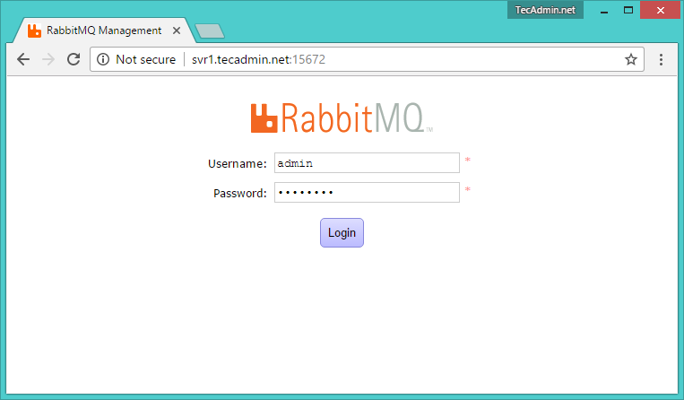
After login, you will get the RabbitMQ management web interface dashboard.
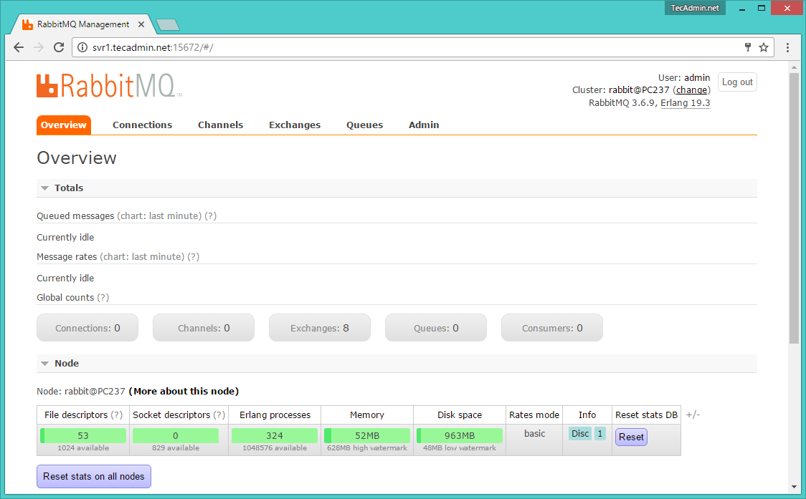

https://www.8host.com/blog/ustanovka-i-upravlenie-rabbitmq/

УСТАНОВКА И УПРАВЛЕНИЕ RABBITMQ
Май 8, 2015 12:19 пп 9 079 views | 2 Comments
Centos, Debian, RHEL, Ubuntu | Amber | 1 Comment
Любой опытный системный администратор знает, что иногда откладывание задач на потом очень полезно и даже необходимо, особенно если задача трудоёмкая и отнимает много ресурсов. Для этого необходим брокер сообщений – программа, которая принимает сообщения (задачи) от различных отправителей (веб-приложений), формирует из них очередь, а затем распределяет их между рабочими процессами.
В данной статье речь пойдёт о проекте RabbitMQ – связке открытых приложений для осуществления функций брокера сообщений, которая реализует протокол Advanced Message Queuing Protocol (AMQP).

Сообщения, брокеры сообщений и очерёдность
Обмен сообщениями – это способ обмена определёнными данными между процессами, приложениями, виртуальными и физическими серверами. Эти сообщения, выполняющие некоторые вычислительные функции, могут содержать практически что угодно, от простого текста до больших блоков двоичных данных. Для корректного выполнения этого процесса необходима сторонняя программа – это и есть брокер сообщений (англ. Message Broker).
Брокер сообщений – это, как правило, группа приложений, каждый отдельный компонент которой предназначен для обработки определённого этапа обмена сообщениями: дл приёма сообщения, определении его в очередь и передаче сообщения рабочему процессу, ответственному за его выполнение. Часто вместо полноценных решений используются программы, изначально не предназначенные для этой работы (базы данных, демон cron, и т.д.); они просто создают очередь сообщений (что технически представляет бесконечные буферы), а затем передают их дл автоматической обработки либо для опроса.

Зачем нужны брокеры сообщений?
Брокеры сообщений выступают в роли посредника между различными сервисами (веб-приложениями). Они существенно снижают нагрузку и сокращают время доставки сообщений, поскольку задачи, на обработку которых уходит некоторое время, распределяются между рабочими процессами, предназначенными исключительно для выполнения этих задач. Они обеспечивают надёжный канал передачи сообщений от одного приложения другому.

Когда нужны брокеры сообщений?
В целом, основная функциональность брокеров сообщений охватывает множество областей, в том числе, но не ограничиваясь:
- Сокращение времен ответа веб-серверов на запросы (поскольку им не приходится выполнять ресурсозатратные задачи);
- Распространение сообщения нескольким адресатам (например, для обработки)
- Пользователи оффлайн могут позже извлечь все данные;
- Полностью асинхронный режим работы с серверными системами;
- Упорядочивание и определение приоритетности задач;
- Балансировка нагрузки между рабочими процессами;
- Повышение надежности и времени безотказной работы приложения;
- И многое другое.

Краткий обзор RabbitMQ
RabbitMQ (вышел в 2007) – это один из наиболее популярных брокеров сообщений с открытым исходным кодом, который поставляется по лицензии Mozilla Public License v1.1 как реализация протокола Advanced Message Queuing Protocol. Разработанный на языке Erlang, RabbitMQ довольно прост в использовании и установке.

Как работает RabbitMQ?
RabbitMQ предоставляет интерфейс, соединяющий отправителей (Publishers) с получателями (Consumers) при помощи брокера, который распределяет данные в соответствующие списки — очереди сообщений (Message Queues).
APPLICATION EXCHANGE TASK LIST WORKER
[DATA] -------> [DATA] ---> [D]+[D][D][D] ---> [DATA]
Publisher EXCHANGE Queue Consumer

Преимущества RabbitMQ
В отличие от других решений, RabbitMQ является полноценным стеком приложений, а не простой базой для применения выбранных вами приложений. Он предоставляет все необходимые инструменты в комплексе.

Краткий обзор AMQP
AMQP (Advanced Message Queuing Protocol) – это широко распространённый открытый стандарт для распространения и передачи сообщений. Как протокол и стандарт, он устанавливает общую основу для взаимодействия различных приложений и брокеров сообщений и устраняет проблемы, вызванные индивидуальным проектированием программ.

Установка RabbitMQ
Пакеты RabbitMQ поставляются системами CentOS/RHEL и Ubuntu/Debian. Но, как правило, такие пакеты устаревшие. Потому рекомендуется скачать и установить RabbitMQ вручную.
Примечание: Все действия руководства рекомендуется выполнять на свежем сервере, чтобы не нарушить работу запущенных ранее приложений и не вызвать сбой настроек.

Установка RabbitMQ в CentOS/RHEL
Прежде чем приступить к установке RabbitMQ, нужно установить зависимости программы, одной из которых является Erlang. Однако, прежде всего необходимо обновить систему и стандартные приложения; для этого запустите:
yum -y update
Для установки Erlang используйте команды:
# Add and enable relevant application repositories:
# Note: We are also enabling third party remi package repositories.
wget http://dl.fedoraproject.org/pub/epel/6/x86_64/epel-release-6-8.noarch.rpm
wget http://rpms.famillecollet.com/enterprise/remi-release-6.rpm
sudo rpm -Uvh remi-release-6*.rpm epel-release-6*.rpm
# Finally, download and install Erlang:
yum install -y erlang
Теперь можно установить RabbitMQ:
# Download the latest RabbitMQ package using wget:
wget http://www.rabbitmq.com/releases/rabbitmq-server/v3.2.2/rabbitmq-server-3.2.2-1.noarch.rpm
# Add the necessary keys for verification:
rpm --import http://www.rabbitmq.com/rabbitmq-signing-key-public.asc
# Install the .RPM package using YUM:
yum install rabbitmq-server-3.2.2-1.noarch.rpm

Установка RabbitMQ в Ubuntu 13/Debian 7
Процесс установки RabbitMQ в Ubuntu/Debian подобен установке в CentOS.
Для начала нужно обновить стандартные пакеты:
apt-get update
apt-get -y upgrade
Включите репозиторий приложения RabbitMQ:
echo "deb http://www.rabbitmq.com/debian/ testing main" >> /etc/apt/sources.list
Добавьте ключ проверки пакета:
curl http://www.rabbitmq.com/rabbitmq-signing-key-public.asc | sudo apt-key add -
Снова обновите систему:
apt-get update
Теперь можно загрузить и установить RabbitMQ:
sudo apt-get install rabbitmq-server
Чтобы при запуске было обработано максимальное количество подключений, откройте и отредактируйте в nano следующий конфигурационный файл:
sudo nano /etc/default/rabbitmq-server
Раскомментируйте строку limit (просто удалите символ #), а затем сохраните и закройте файл (CTRL+X + Y).

Управление RabbitMQ
Как говорилось ранее, брокер RabbitMQ очень прост в использовании. В данном разделе приведены инструкции по управлению и настройке RabbitMQ.

Включение консоли управления
Консоль управления RabbitMQ (RabbitMQ Management Console) – это один из доступных плагинов, позволяющий мониторить процессы сервера RabbitMQ через графический пользовательский веб-интерфейс.
При помощи этой консоли можно:
- Управлять обменом сообщениями, очередями сообщений, подключениями и пользователями;
- Отслеживать очереди сообщений, соединения и скорость передачи сообщений;
- Отправлять и получать сообщения;
- Отслеживать процессы Erlang и использование памяти;
- И многое другое.
Чтобы включить консоль RabbitMQ, запустите команду:
sudo rabbitmq-plugins enable rabbitmq_management
Теперь можно открыть консоль при помощи любого удобного браузера:
http://[IP_адрес_сервера]:15672/.
Стандартные имя и пароль – guest.
Примечание: Запустив консоль после запуска сервиса, не забудьте перезапустить его, чтобы обновить настройки.

Управление RabbitMQ в CentOS/RHEL
После установки приложение RabbitMQ не будет запускаться автоматически при загрузке системы.
Чтобы настроить автозапуск RabbitMQ, выполните:
chkconfig rabbitmq-server on
Для запуска, остановки, перезапуска и проверки состояния используйте команды:
# Запуск:
/sbin/service rabbitmq-server start
# Остановка:
/sbin/service rabbitmq-server stop
# Перезапуск:
/sbin/service rabbitmq-server restart
# Проверка статуса:
/sbin/service rabbitmq-server status

Управление RabbitMQ в Ubuntu/Debian
Чтобы запустить, остановить перезапустить и проверит статус приложения в Ubuntu и Debian, используйте:
# Запуск:
service rabbitmq-server start
# Остановка:
service rabbitmq-server stop
# Перезапуск:
service rabbitmq-server restart
# Проверка статуса:
service rabbitmq-server status
Готово! Теперь на сервере есть готовый к работе брокер сообщений.

Настройка RabbitMQ
RabbitMQ поставляется со стандартными настройками. В целом, они довольно надёжны инее требуют редактирования.
Чтобы получить информацию о пользовательской настройке RabbitMQ, обратитесь к документации приложения.

